CS221 Lab7 Animation: The bouncing ball. Worth: 5 points

Objectives:
- Introduction to AWT and Swing.
- Practice using two-dimensional graphic shapes.
- Work with an event-driven program.
- Practice using timers.

- Enter BlueJ.
Part I: Create a project with the three classes, BallApp, BallPanel and SmartEllipse. Compile, run and test the project.

Paste a screenshot of the original program below:
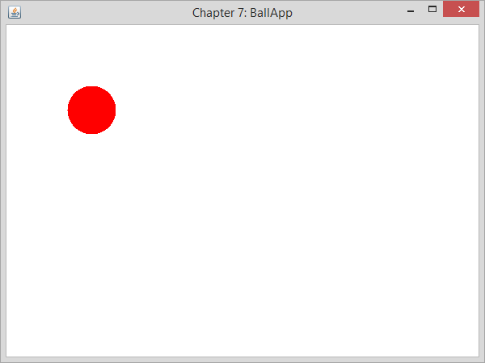

- Modify the source code to change the title of the frame, the color, size, and location of the ball and the size of the window. Compile, run and test the modified program.

Paste a screenshot of the JFrame of the changed program below:
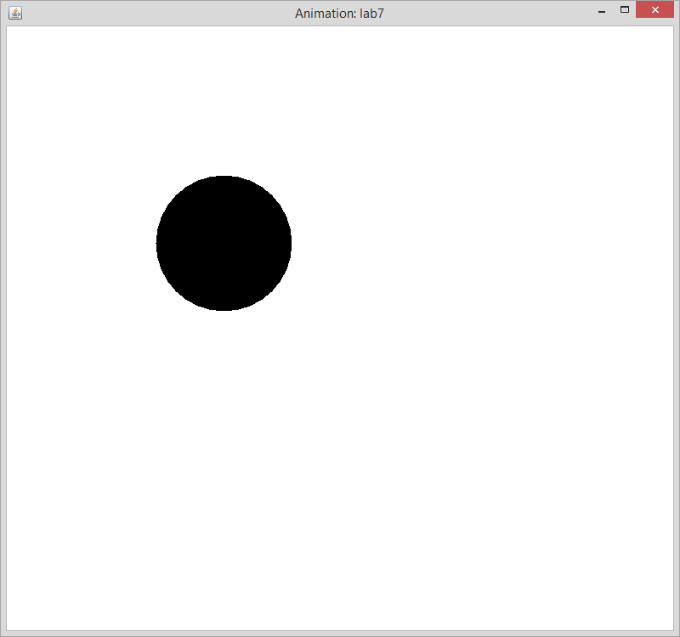

Provide the source code of all the Java you changed (from the original) in order to change the title of the frame, the color, size, and location of the ball and the size of the window:
/** BallPanel.java
* Creates the panel to be placed inside the BallApp window.
* */
public class BallPanel extends javax.swing.JPanel {
private final int INIT_X = 175; // attributes
private final int INIT_Y = 175;
private final int DIAMETER = 160;
private SmartEllipse _ball; // component

public BallPanel () {
super();
_ball = new SmartEllipse (java.awt.Color.black);
this.setBackground(java.awt.Color.white);
_ball.setLocation(INIT_X, INIT_Y);
_ball.setSize(DIAMETER, DIAMETER);
}
public void paintComponent (java.awt.Graphics aBrush) {
super.paintComponent(aBrush);
java.awt.Graphics2D betterBrush =
(java.awt.Graphics2D) aBrush;
_ball.fill(betterBrush);
}
}

/** BallApp.java
* Displays a window with a red circle on a white background. */

public class BallApp extends javax.swing.JFrame {
public BallApp (String title) {
super(title);
this.setSize(800, 750);
this.setDefaultCloseOperation
(javax.swing.JFrame.EXIT_ON_CLOSE);
this.add(new BallPanel());
this.setVisible(true);
}

public static void main (String [ ] args) {
BallApp app = new BallApp ("Animation: lab7");
}
}

, Original Program
/** BallApp.java  * Displays a window with a red circle on a white background. */  public class BallApp extends javax.swing.JFrame {  public BallApp (String title) {  super(title);  this.setSize(600, 450);  this.setDefaultCloseOperation  (javax.swing.JFrame.EXIT_ON_CLOSE);  this.add(new BallPanel());  this.setVisible(true);  }  public static void main (String [ ] args) {  BallApp app = new BallApp ("Chapter 7: BallApp");  }  }  /** BallPanel.java  * Creates the panel to be placed inside the BallApp window.  public class BallPanel extends javax.swing.JPanel {  private final int INIT_X = 75; // attributes  private final int INIT_Y = 75;  private final int DIAMETER = 60;  private SmartEllipse _ball; // component  public BallPanel () {  super();  _ball = new SmartEllipse (java.awt.Color.red);  this.setBackground(java.awt.Color.white);  _ball.setLocation(INIT_X, INIT_Y);  _ball.setSize(DIAMETER, DIAMETER);  }  public void paintComponent (java.awt.Graphics aBrush) {  super.paintComponent(aBrush);  java.awt.Graphics2D betterBrush =  (java.awt.Graphics2D) aBrush;  _ball.fill(betterBrush);  }  } | /**  * SmartEllipse.java  * Extends Java's Ellipse2D.Double class, adding the capabilities  * to set location, and size, and to display itself on a panel.  */  public class SmartEllipse extends java.awt.geom.Ellipse2D.Double {  private java.awt.Color _borderColor, _fillColor; // attributes  public SmartEllipse(java.awt.Color aColor){  super();  _borderColor = aColor;  _fillColor = aColor; // solid color to start  }  // more readable versions of methods provided by Java  public void setLocation (double x, double y) {  this.setFrame (x, y, this.getWidth(),  this.getHeight());  }  public void setSize (int aWidth, int aHeight) {  this.setFrame(this.getX(), this.getY(),  aWidth, aHeight);  }  public void fill (java.awt.Graphics2D aBetterBrush){  java.awt.Color savedColor = aBetterBrush.getColor();  aBetterBrush.setColor(_fillColor);  aBetterBrush.fill(this); // paint a solid ellipse  aBetterBrush.setColor(savedColor);  }  }

Part II: Animation:
- Now we will introduce animation.
a) You will need to add two new classes: MoveTimer and Bouncing Ball as well as the interface, Mover. You will also need to modify the BallPanel class. Compile, run and test the modified program. Write the title, “Animation and then copy the source code and at least two screenshots of the ball on the panel onto a word document. Also, take a screenshot of the BlueJ class diagrams and paste into Word. [Try to untangle the lines representing the relationships among the classes and interface as much as possible]

- [Hint: in order to change the speed of the ball, you need to change the value of one of the parameters in the constructor when _timer is created. You can check online for information on the constructor in class javax.swing.Timer.] Compile, run and test the modified program. Write the title “Modification 1 of Animation” and copy only those classes that were modified into a word document
- Now modify the source code to add another ball of another color, size and beginning location. Compile, run and test the modified program. Write the title “Modification 2 of Animation”, copy only those classes that were modified into a word document along with at least two screenshots of the balls on the panel onto a word document.

- Please send your word document to BlackBoard and log out.

Animation:
/**  * MoveTimer.java  * A subclass of javax.swing.Timer that can be used  * for animation. It also serves as an example of the  * code for an "event source" object.  public class MoveTimer extends javax.swing.Timer {  private Mover _mover; // peer object  public MoveTimer (int anInterval, Mover aMover) {  super(anInterval, null);  _mover = aMover;  this.addActionListener(new MoveListener());  }  private class MoveListener implements java.awt.event.ActionListener {  public void actionPerformed(java.awt.event.ActionEvent e){  _mover.move();  }  }  }  /**  * Mover.java  * Interface for objects that can move to a specified location.  * Must be implemented by objects that respond to a MoveTimer.  */  public interface Mover {  public void move();  } | /** BouncingBall.java  * Extends SmartEllipse, adding the ability to "bounce." */  public class BouncingBall extends SmartEllipse implements Mover {  private int _changeX, _changeY; // attributes  private final int MOVE_LEN = 5;  private javax.swing.JPanel _panel; // peer object (and container)  private javax.swing.Timer _timer;  public BouncingBall (java.awt.Color aColor,  javax.swing.JPanel aPanel){  super(aColor); //2a  _changeX = MOVE_LEN;  _changeY = MOVE_LEN;  _panel = aPanel;  }  public void move() {  int nextX = (int)this.getX() + _changeX; // 2b  int nextY = (int)this.getY() + _changeY;  if (nextX <= this.getMinBoundX()) {  _changeX *= -1;  nextX = this.getMinBoundX();  }  else if (nextX >= this.getMaxBoundX()) {  _changeX *= -1;  nextX = this.getMaxBoundX();  }  if (nextY <= this.getMinBoundY()) {  _changeY *= -1;  nextY = this.getMinBoundY();  }  else if (nextY > this.getMaxBoundY()){  _changeY *= -1;  nextY = this.getMaxBoundY();  }  this.setLocation(nextX, nextY); //2c  }  public int getMinBoundX() {  return (int) _panel.getX(); //2d  }  public int getMinBoundY() {  return (int) _panel.getY();  }  public int getMaxBoundX() {  return (int) (_panel.getX() + _panel.getWidth()  - this.getWidth());  }  public int getMaxBoundY() {  return (int) (_panel.getY() + _panel.getHeight()  - this.getHeight());  }  }

/**
*: BallPanel.java
* Creates the panel to be placed inside the BallApp window.
* *
*/
public class BallPanel extends javax.swing.JPanel implements Mover {
private final int INIT_X = 75; // attributes
private final int INIT_Y = 75;
private final int DIAMETER = 60;
private final int INTERVAL = 100;
private BouncingBall _ball; // components
private MoveTimer _timer;

public BallPanel () {
super();
_ball = new BouncingBall (java.awt.Color.red, this);
_timer = new MoveTimer(INTERVAL, this);
this.setBackground(java.awt.Color.white);
_ball.setLocation(INIT_X, INIT_Y);
_ball.setSize(DIAMETER, DIAMETER);
_timer.start();
}

public void move() {
_ball.move();
this.repaint();
}

public void paintComponent (java.awt.Graphics aBrush) {
super.paintComponent(aBrush);
java.awt.Graphics2D betterBrush =
(java.awt.Graphics2D) aBrush;
_ball.fill(betterBrush);
}
}

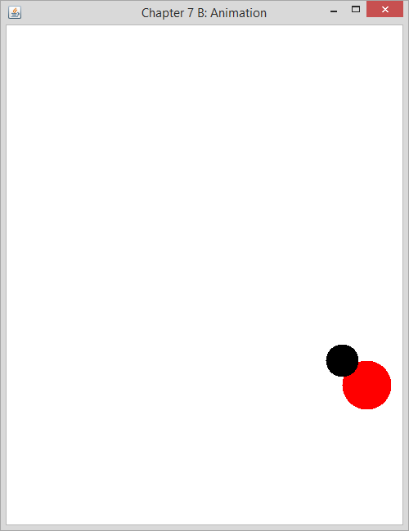

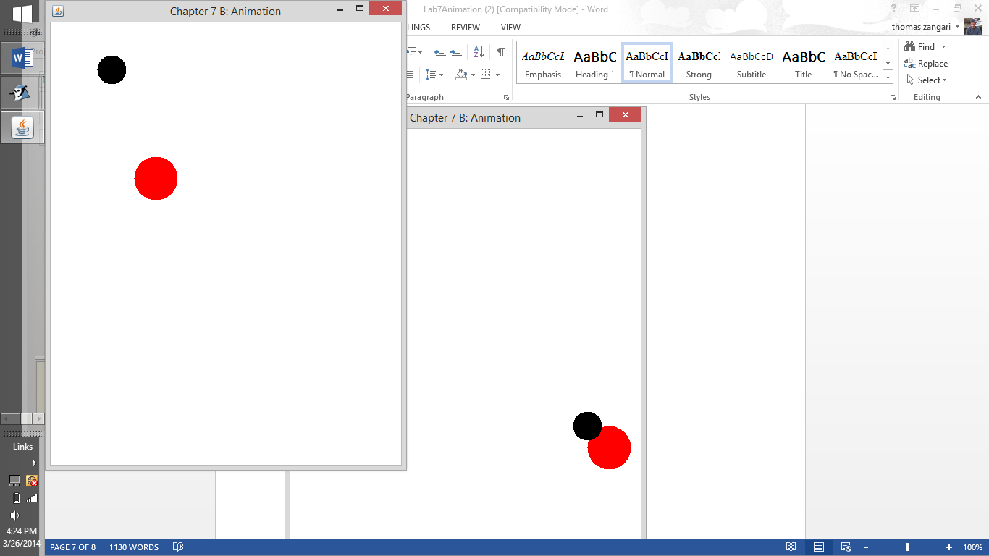

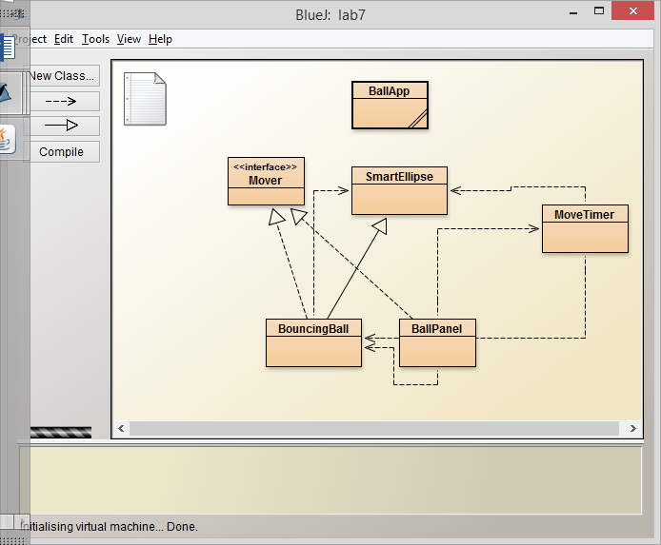

/**
*: BallPanel.java
* Creates the panel to be placed inside the BallApp window.
* *
*/
public class BallPanel extends javax.swing.JPanel implements Mover {
private final int INIT_X = 75; // attributes
private final int INIT_Y = 75;
private final int DIAMETER = 60;
private final int INTERVAL = 100;
private BouncingBall _ball; // components
private MoveTimer _timer;
private BouncingBall _ball2;

public BallPanel () {
super();
_ball = new BouncingBall (java.awt.Color.red, this);
_ball2 = new BouncingBall (java.awt.Color.black, this);
_timer = new MoveTimer(INTERVAL, this);
this.setBackground(java.awt.Color.white);
_ball.setLocation(INIT_X, INIT_Y);
_ball.setSize(DIAMETER, DIAMETER);
_ball2.setLocation(INIT_X - 20, INIT_Y - 20);
_ball2.setSize(DIAMETER - 20, DIAMETER - 20);
_timer.start();
}

public void move() {
_ball.move();
_ball2.move();
this.repaint();
}

public void paintComponent (java.awt.Graphics aBrush) {
super.paintComponent(aBrush);
java.awt.Graphics2D betterBrush =
(java.awt.Graphics2D) aBrush;
_ball.fill(betterBrush);
_ball2.fill(betterBrush);
}
}

Lab: Part II [Worth: 1 pt]

Use the on-line documentation fron Sun

1. Look up: javax.swing.Timer [The class Timer in the package javax.swing]

a) How many constructors are there? ___1________
b) Provide the signature of the constructor_Timer(int delay, ActionListener listener)_______________________________
c) Fill in the following table, describing the following methods that are defined in javax.swing.Timer

Method Name | Description of Method | Signature of Method | Which class in the Groupwork uses this method?
addActionListener | Adds an action listener to the Timer. | listener - the listener to add | MoveTimer
start | Starts the Timer, causing it to start sending action events to its listeners. | No signature | BAllPanel

2) In the BouncingBall class, fill in the following table for methods used there. [You will need to use the on-line Sun documentation to find the purpose and the class in which the method is defined.]

Method Call | Purpose of Method | In what class is method defined?
a) super(aColor); | It to use the super class component of coloe | SmartEllipse
b) (int) this.getX(); | Returns the X coordinate of the upper-left corner of the framing rectangle in double or float precision. | BallPan
c) this.setLocation(nextX, nextY); | Moves this component to a new location. The top-left corner of the new location is specified by the xand y parameters in the coordinate space of this component's parent.  This method changes layout-related information, and therefore, invalidates the component hierarchy.  The method changes the geometry-related data. Therefore, the native windowing system may ignore such requests, or it may modify the requested data, so that the Window object is placed and sized in a way that corresponds closely to the desktop settings. | BallPan
d) return (int) _panel.getX(); | Returns the current y coordinate of the component's origin. This method is preferable to writingcomponent.getBounds().y, or component.getLocation().y because it doesn't cause any heap allocations. | BouncingBall

